Answer the questions 1-3 below. Label the parts of the communication modes.
1. What are the differences between the communication models (Found in chapter 1.2 of your book, pages 24-32)?
The three models found in text book differ in the way messages move, how feedback functions and how meaning is created: transmission, interaction and transactional models of communication.
Transmission Model of Communication:
This model describes communication as linear process where in a sender intentionally transmits a message to a receiver and meaning is assumed to reside in the message itself. Noise may occur to interfere with the message but communication does not account for context or simultaneous interaction.
Interaction Model of Communication:
This model of communication posits communication as a directional process where participants change positions in an exchange: first one is a sender then the other becomes a sender. Meaning is created with messages and feedback and physical or psychological contexts. With feedback the communication is not simultaneous because participants take turns sending and receiving a message.
Transactional Model of communication:
This model reiterates that the communication process is simultaneous between communicators who are both sender and receivers simultaneously and meaning is co created within these social, relational and cultural contexts. This approach acknowledges that communication helps to construct social realities and is shaped by norms, relationships and cultural identities themselves.
2. Give an example for each communication model.
Transmission: A public service announcement on television where information is delivered to viewers without any opportunity for feedback.
Interaction: Sending an email and later receiving a reply. The participants alternate roles as sender and receiver.
Transactional: A face to face conversation between friends where both people speak, listen, interpret nonverbal cues and respond simultaneously.

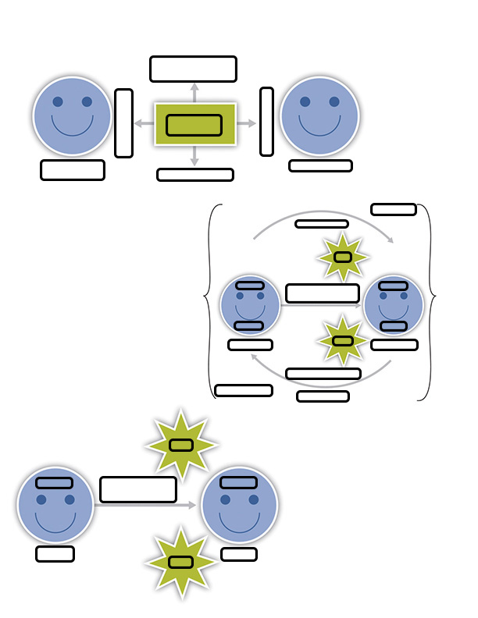

3. Label the parts to the different communication mode
Physical and Psychological Context

Creation of
Meaning
Encoding
Decoding
Receiver
Noise
Noise
Decoding
Decoding
Encoding
Encoding
Sender/
Receiver
Sender/
Receiver
Psychological Context
Feedback
Sender
Message
Communicator

Feedback
Message
Message
Relational Context
Communicator

Communicator

Cultural Context
Social Context

